Practical 9: Explore the utility tool NetCat.

**Private Chat**:- download netcat file from browser. On both system open that file location cmd Type given code in screenshot. Using that that code you can make your private chat.

# ScreenShot:-

# 

# 

**FileTransfer**:-fromonesystem“nc-l-v-p12345<abc.txt”usingthiscommandthisfile send on port no 12345 .in another system type this command “nc ip 12345> abc.txt” you can download or access that file.

# Screenshot:

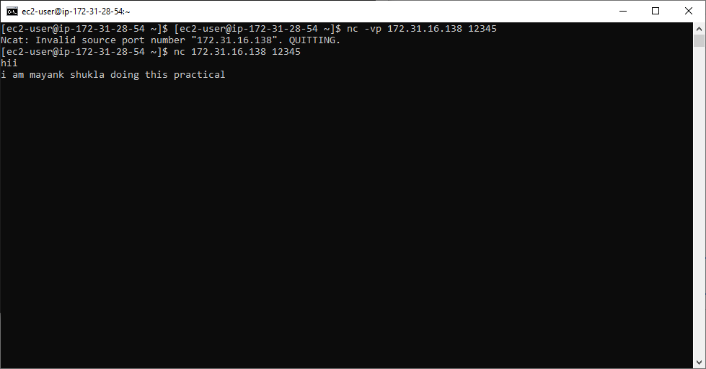

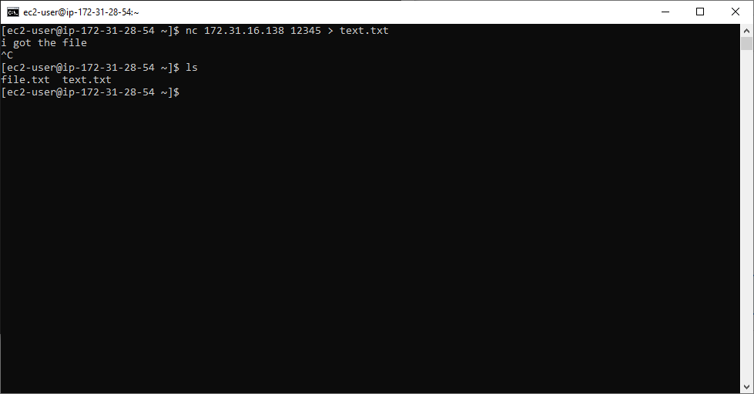

**Accesing CMD/terminal of other pc** :- first write command “nc ip 12345” on that pc from which you want access cmd of other pc . after that write command “nc-l-v-p12345 -e cmd.exe” from pc-2 now cmd is accessed now you can anything which you want do in pc-2 from pc-1`s cmdin below given screen shot we delete one file which on desktop in pc-2 but we delete

frompc-1`scmd.

**ScreenShot:-**

